Landowner Report
Station Information
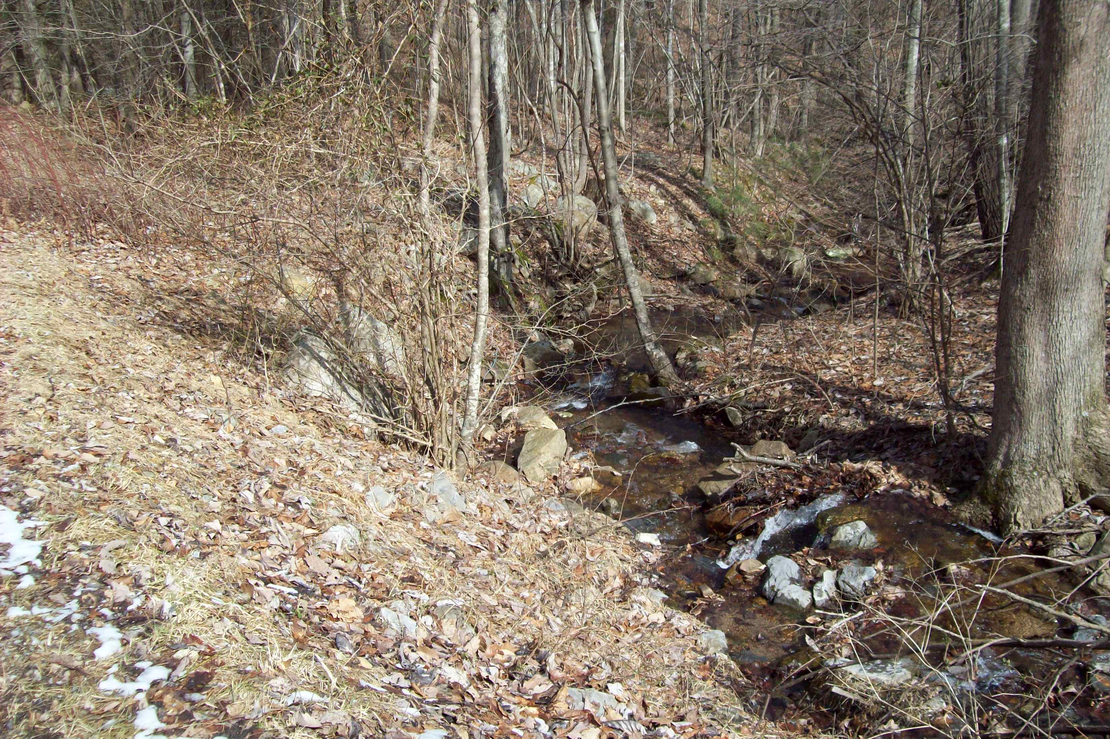
Station ID 4AXOH000.06
Stream Name Unnamed Tributary to South Fork Goose Creek
Description Off of Audrey Drive near Montvale
Year 2014
Regional Office BRRO-Roanoke
County Bedford
Basin Roanoke Photo of sampling station

Data Results
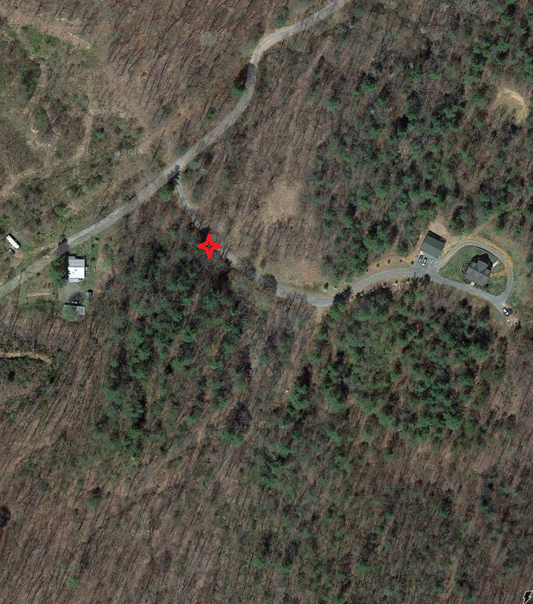
Spring Fall Status
Temperature(C/F) 6.9 14.5 Optimal
Dissolved Oxygen(mg/l) 11.7 9.9 Optimal
pH 7.3 7.7 Optimal
Conductivity (uS) 32 40 Optimal
Bacteria (cfu/100 ml) 180 Optimal
Total Nitrogen (mg/l) 0.08 0.32 Optimal
Total Phosphorus (mg/l) 0.07 0.13 Optimal
Metals Index (ccu) 0.05 Optimal Approximate location of station
Biological Index (0-100) 74.1 71.0 Optimal
Habitat Index (0-200) 167 141 Optimal

The 'Landowner Report’ is not an official site specific VDEQ water quality assessment. This report summarizes water quality findings based on a limited sampling event. The primary application of probabilistic monitoring data is to establish regional/statewide water quality conditions and not to perform a site specific characterization. Please see the enclosed insert for more information.

Biologist Comments:
This site was sampled as a part of the Probabilistic Monitoring Program in 2014. The site was in a small headwater stream that had good numbers of mayflies in the spring and stoneflies in the fall. Overall, the benthic community had good diversity and high numbers of pollution-sensitive taxa. Most habitat scores were good except for sediment deposition in the fall when the stream was at low flow conditions.
Biologist Contact Information:
Larval stonefly “indicator of good water quality”
George Devlin
Regional Biologist
VDEQ BRRO-Roanoke
3019 Peters Creek Road
Roanoke, VA 24109
Phone: 540-562-6826
Email: george.devlin@deq.virginia.gov

